Snub Dodecahedron

Definition
# Source: AI Source: Provided by: [Data Path: Persons Table -> ID Column: 1, Name_En Column: Motasem Essam] -> From: [ChatGPT] on [7/25/2026]
The Snub Dodecahedron, also known as the Snub Icosidodecahedron or Dodecahedron Simum, is a convex Archimedean solid composed of 80 equilateral triangular faces and 12 regular pentagonal faces.
It has 150 edges and 60 vertices. Its defining characteristics are its twisted arrangement of faces and its chiral structure, meaning it exists in two distinct mirror-image forms: left-handed and right-handed.
It is one of the 13 Archimedean solids and has the greatest number of faces among them.

Geometric Structure
# Source: AI Source: Provided by: [Data Path: Persons Table -> ID Column: 1, Name_En Column: Motasem Essam] -> From: [ChatGPT] on [7/25/2026]
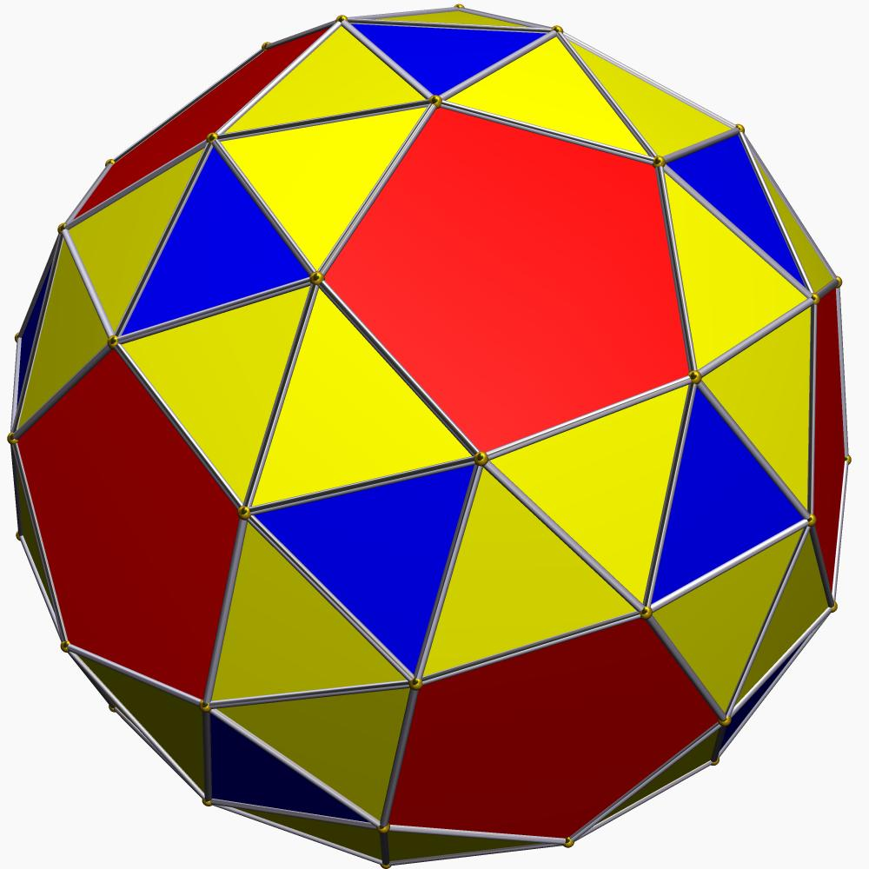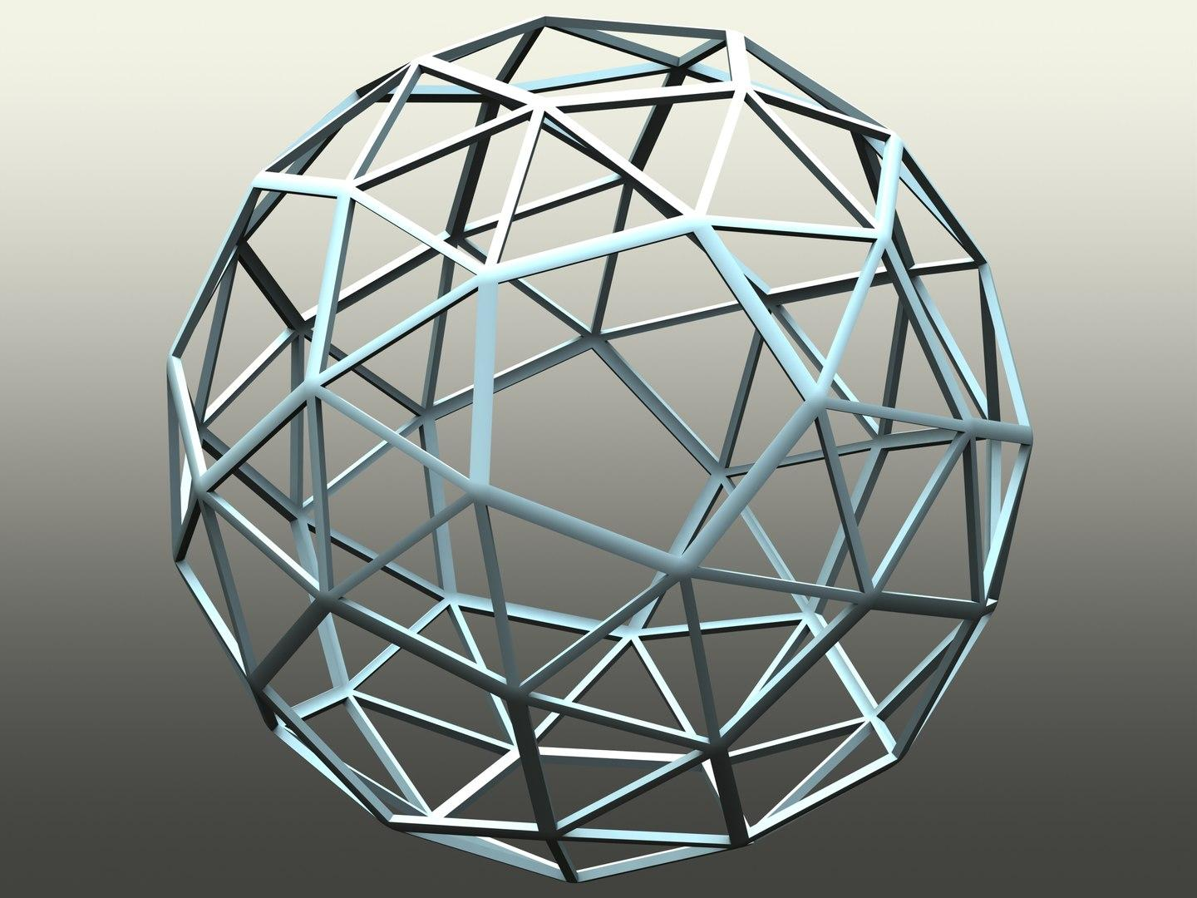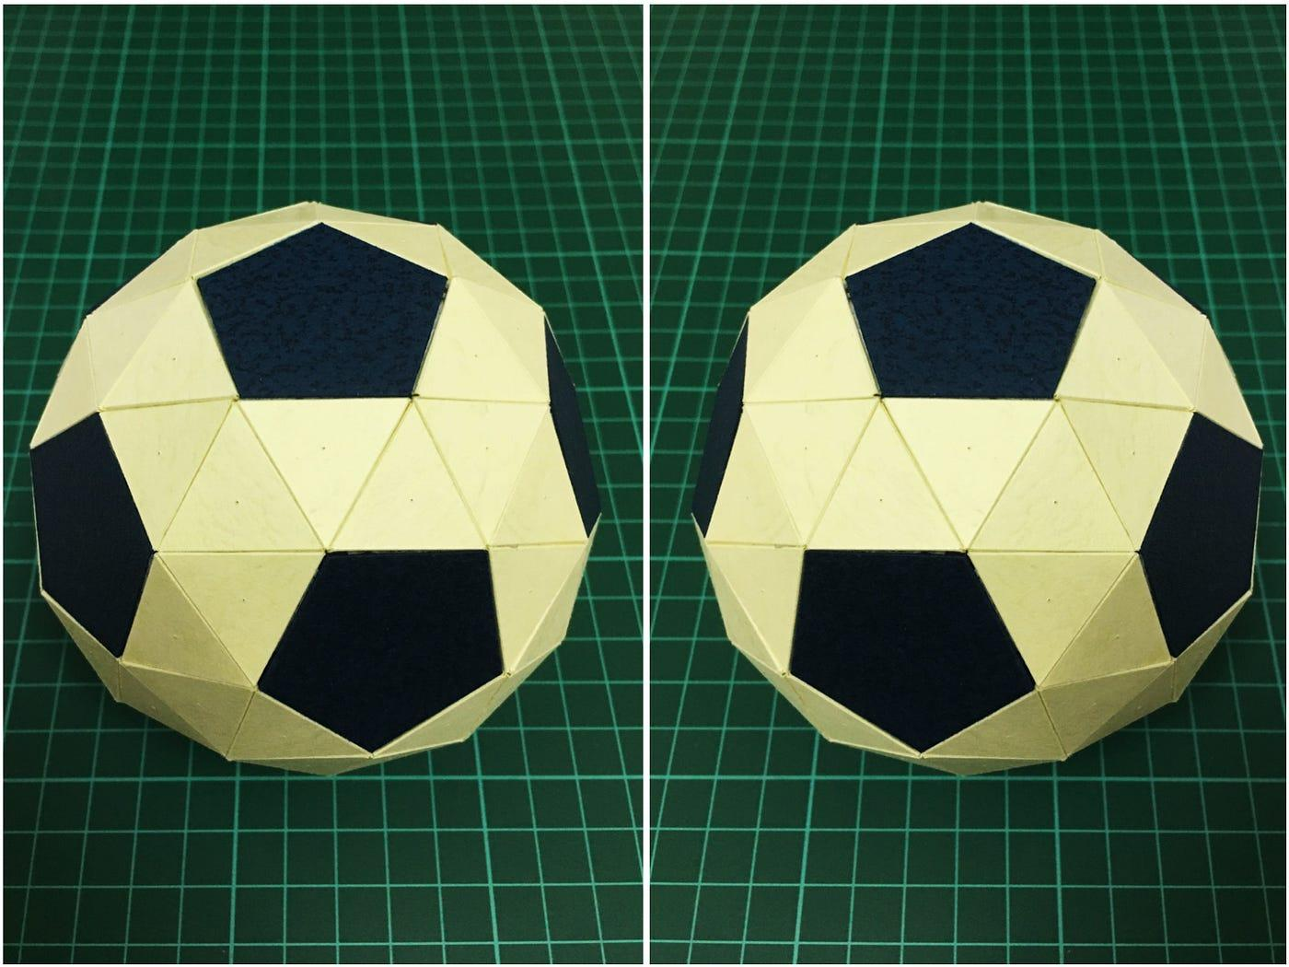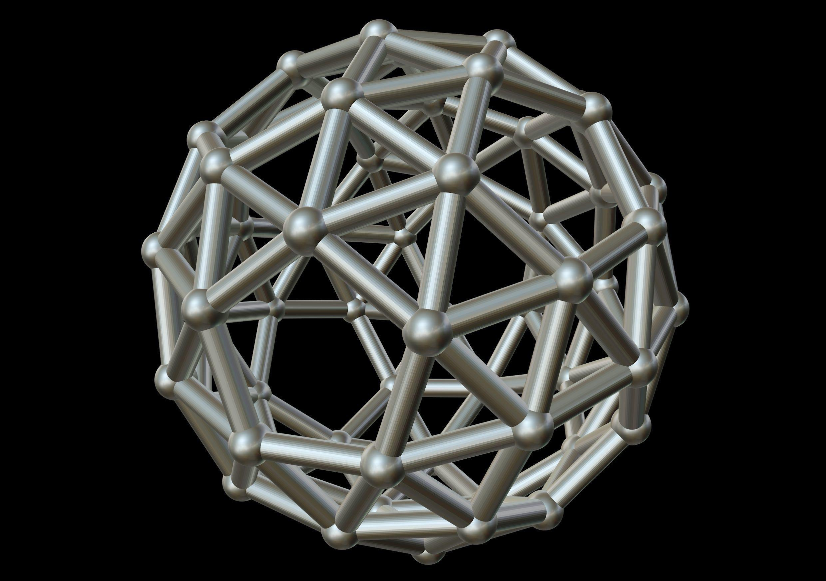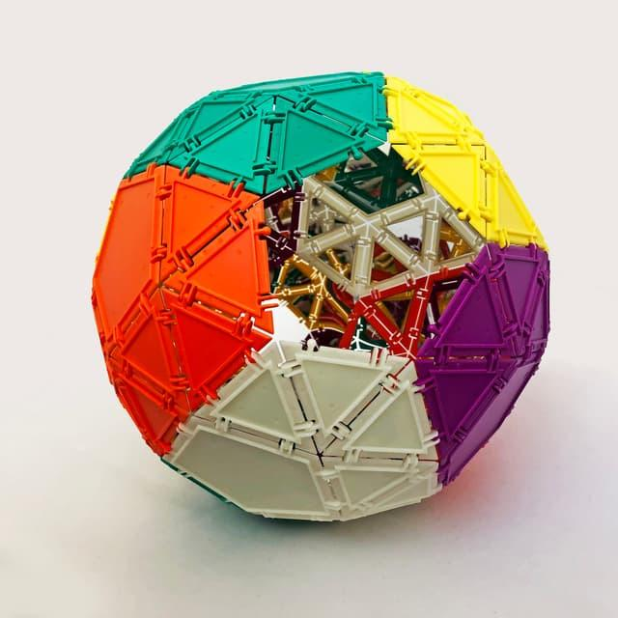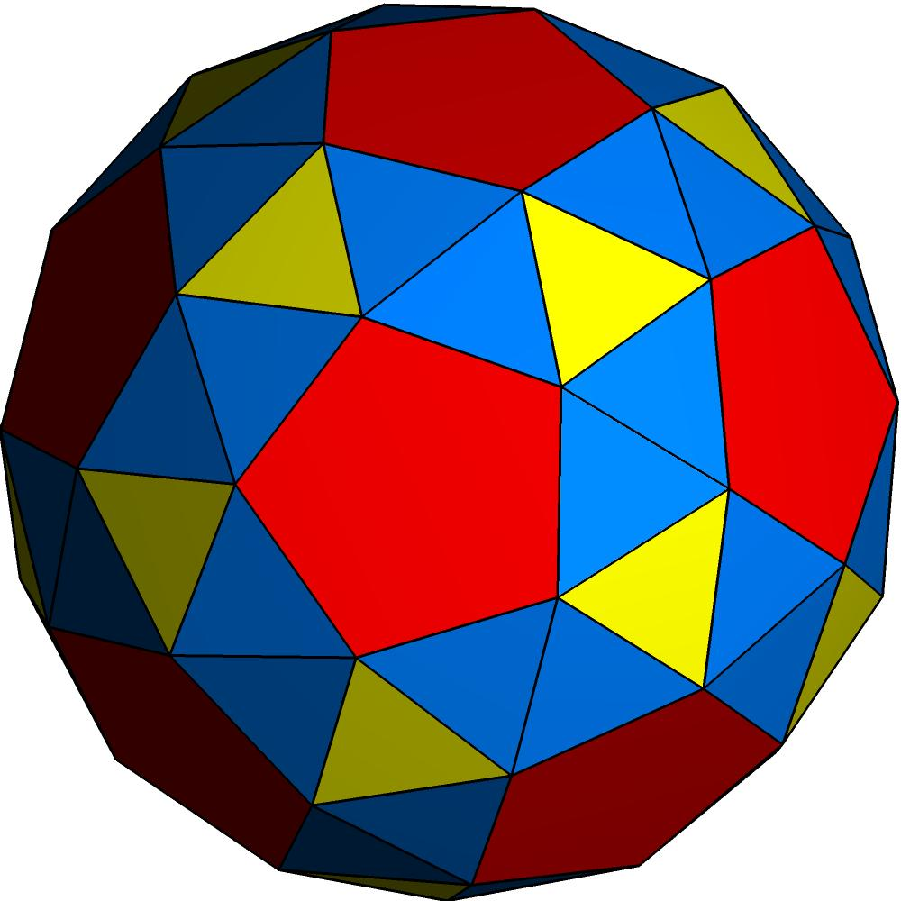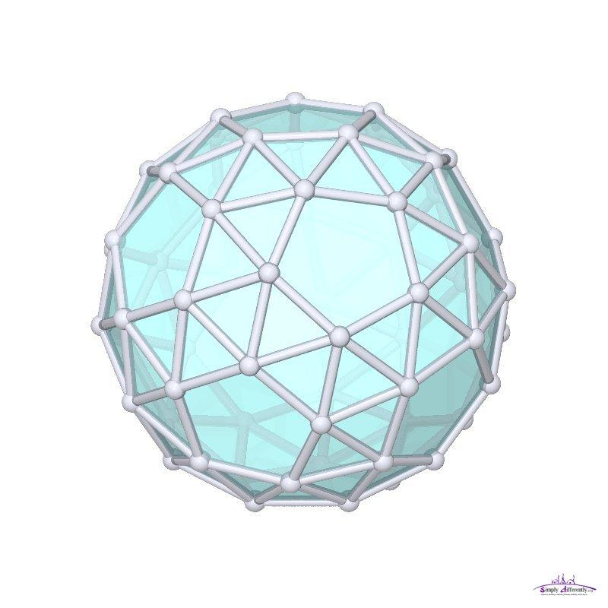
The solid consists of two types of regular polygonal faces:
- 80 Equilateral Triangles: Form most of the surface and connect the pentagonal faces.
- 12 Regular Pentagons: Arranged in a twisted pattern around the solid.
- Snub Arrangement: The triangular faces fill the spaces between the pentagons, creating a twisted three-dimensional structure.
- Two Enantiomorphs: The left-handed and right-handed forms are mirror images that cannot be superimposed through rotation alone.

Face Composition
# Source: AI Source: Provided by: [Data Path: Persons Table -> ID Column: 1, Name_En Column: Motasem Essam] -> From: [ChatGPT] on [7/25/2026]
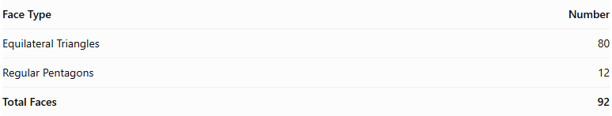
Face Type | Number
Equilateral Triangles | 80
Regular Pentagons | 12
Total Faces | 92
All faces are regular polygons, and all edges have equal length.

Mathematical Properties
# Source: AI Source: Provided by: [Data Path: Persons Table -> ID Column: 1, Name_En Column: Motasem Essam] -> From: [ChatGPT] on [7/25/2026]
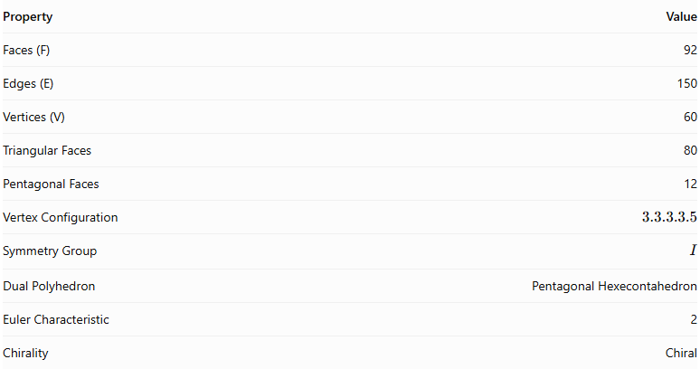
Property | Value
Faces (F) | 92
Edges (E) | 150
Vertices (V) | 60
Triangular Faces | 80
Pentagonal Faces | 12
Vertex Configuration | $$3.3.3.3.5$$
Symmetry Group | $$I$$
Dual Polyhedron | Pentagonal Hexecontahedron
Euler Characteristic | 2
Chirality | Chiral
Euler characteristic:
$$V-E+F=60-150+92=2$$
Approximate surface area (where $a$ is the common edge length):
$$A≈55.287a^{2}$$
Approximate volume:
$$V_{solid}≈37.617a^{3}$$

Geometric Characteristics
# Source: AI Source: Provided by: [Data Path: Persons Table -> ID Column: 1, Name_En Column: Motasem Essam] -> From: [ChatGPT] on [7/25/2026]
- Convex Structure: All faces form a convex, closed polyhedral surface.
- Uniform Faces: All faces are regular polygons, with equal edge lengths throughout the solid.
- Vertex Arrangement: Four equilateral triangles and one regular pentagon meet at every vertex.
- Chirality: The solid has two mirror-image forms that cannot be superimposed through rotation.
- Icosahedral Symmetry: It has chiral icosahedral symmetry, represented by the group $I$, of order 60.
- Twisted Arrangement: The pentagonal faces are connected through a carefully arranged network of triangular faces.

Geometric Construction
# Source: AI Source: Provided by: [Data Path: Persons Table -> ID Column: 1, Name_En Column: Motasem Essam] -> From: [ChatGPT] on [7/25/2026]
The Snub Dodecahedron can be generated through a snubification operation applied to a dodecahedral arrangement.
- Begin with a dodecahedron-based geometric arrangement.
- Introduce a consistent rotational twist into the arrangement.
- Position the pentagonal faces and connect them with equilateral triangles.
- Complete the surface with 80 triangular faces and 12 pentagonal faces.
Reversing the direction of the twist produces the opposite enantiomorph.
The solid can also be described using the Wythoff construction with the symbol:
$$|235$$

Related Geometric Solids
# Source: AI Source: Provided by: [Data Path: Persons Table -> ID Column: 1, Name_En Column: Motasem Essam] -> From: [ChatGPT] on [7/25/2026]
- Dodecahedron – A related Platonic solid used as a geometric reference for snub construction.
- Icosidodecahedron – A related Archimedean solid.
- Snub Cube – Another chiral Archimedean solid.
- Pentagonal Hexecontahedron – The dual polyhedron.

Main Classification
# Source: AI Source: Provided by: [Data Path: Persons Table -> ID Column: 1, Name_En Column: Motasem Essam] -> From: [ChatGPT] on [7/25/2026]
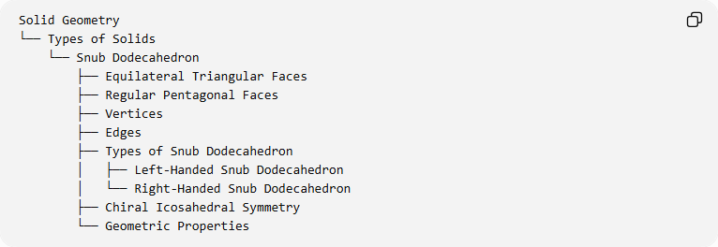
Solid Geometry
└── Types of Solids
└── Snub Dodecahedron
├── Equilateral Triangular Faces
├── Regular Pentagonal Faces
├── Vertices
├── Edges
├── Types of Snub Dodecahedron
│ ├── Left-Handed Snub Dodecahedron
│ └── Right-Handed Snub Dodecahedron
├── Chiral Icosahedral Symmetry
└── Geometric Properties

Key Points
# Source: AI Source: Provided by: [Data Path: Persons Table -> ID Column: 1, Name_En Column: Motasem Essam] -> From: [ChatGPT] on [7/25/2026]
- The Snub Dodecahedron is a convex Archimedean solid.
- It contains 80 equilateral triangles and 12 regular pentagons.
- It has 92 faces, 150 edges, and 60 vertices.
- Four triangles and one pentagon meet at every vertex.
- It exists in left-handed and right-handed forms.
- Its dual is the Pentagonal Hexecontahedron.
- It has the greatest number of faces among the 13 Archimedean solids.

Conclusion
# Source: AI Source: Provided by: [Data Path: Persons Table -> ID Column: 1, Name_En Column: Motasem Essam] -> From: [ChatGPT] on [7/25/2026]
The Snub Dodecahedron is a distinctive Archimedean solid characterized by its 92 regular polygonal faces, twisted arrangement, and chiral symmetry. Its two mirror-image forms and its dual relationship with the Pentagonal Hexecontahedron make it an important example of geometric symmetry and duality.

